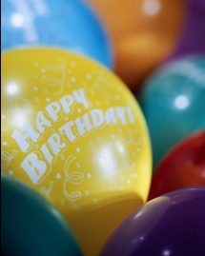
Birthday Celebration Ideas

We will have a 15 minute celebration
Students do not need to bring anything from home for celebration
1. Recess
2. Jams
3. Smart moves
4. Science experiment
5. Literature film
6. Play with play dough
7. Class game outside: Tag, Hide & Seek, Red Rover, race, 4 square, P-I-G
8. Class game inside: Switch it up, 4 corners, Heads Up 7-up, hot potato
9. Student reads a book to the class
10. Origami
11. Core free choice
12. Math Activities: Pattern blocks, flats, longs, & cubes, geoboards
13. Craft: snowflakes
14. Blow bubbles
15. Write with sidewalk chalk

